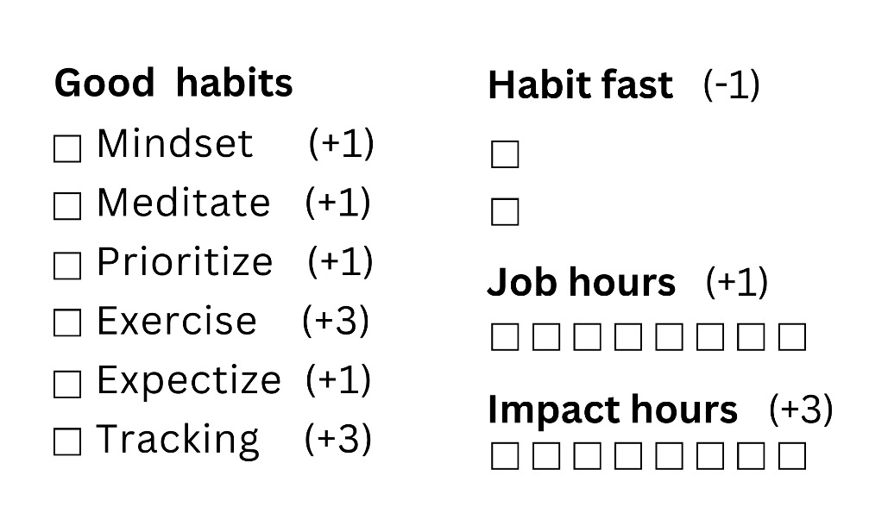 | 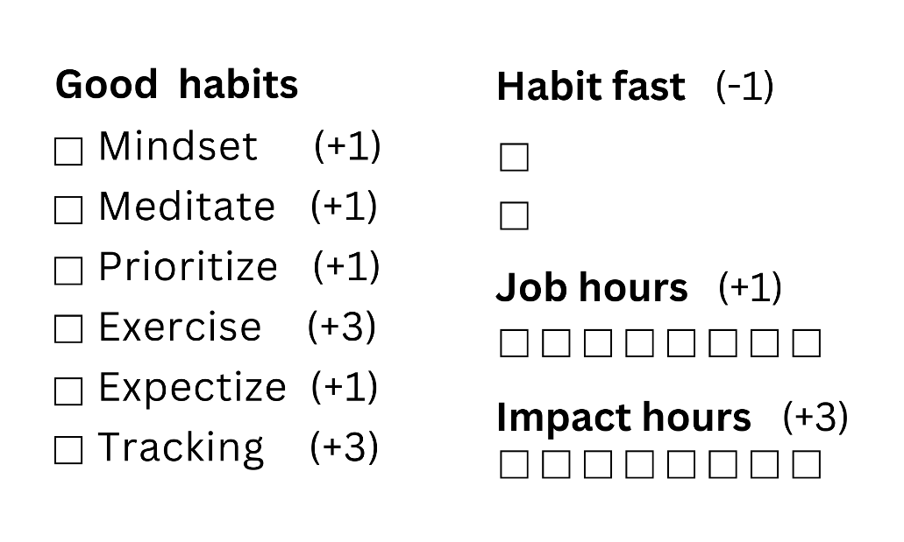

PRINT PAGE 1 ONLY
(NOT THIS PAGE 2)

CUT ALONG THE LINES FOR
6 DAILY SCORECARDS

USE THE BACK OF SCORECARDS
TO PRIORITIZE HIGH-IMPACT TASKS

